Subdomain Enumeration Tool

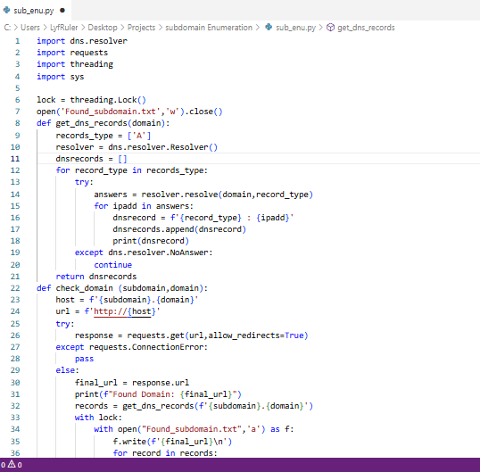
Name: Subdomain Enumeration and DNS Record Retrieval Tool
Introduction:
It identifies hidden subdomains of a target domain, which may reveal unlisted services or potential attack vectors. This project automates subdomain discovery, verifies live domains using HTTP first (then HTTPS fallback), and retrieves DNS A records for each live subdomain.
Methodology / Working
- Input: The user provides the target domain (e.g. example.com).
- Subdomain List: Reads potential subdomains from subdomain.txt.
- Multithreading: Each subdomain is scanned in a separate thread to reduce execution time.
- Domain Verification:
- Attempts HTTP connection first; if it fails, tries HTTPS.
- Uses requests with allow_redirect=True and a 5-second timeout.
- Ensures that HTTPS-only subdomains are also detected.

- DNS Records Retrieval:
- For live subdomains, fetches DNS A records using dns.resolver
- Output:
- Prints results to the console.
- Saves results to found_subdomain.txt in the following format:
- Thread Safety: Uses a thread lock to prevent simultaneous file writes.
Flow chart
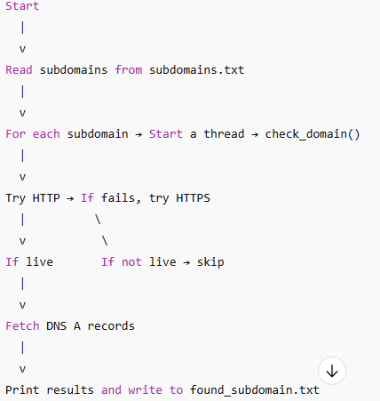

Output
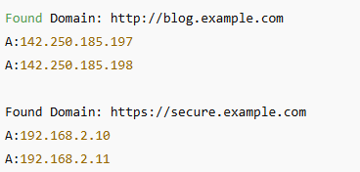

PDF Encryption Tool

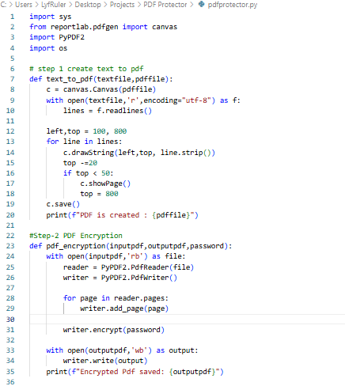
Name: Automated Text-to-PDF Conversion and Encryption Tool
Introduction: This project automates the conversion of plain text files into PDF documents and protects them with a password. It is useful for generating secure reports, notes, or sensitive information, ensuring confidentiality and easy access.
Working of the Code
- User Input:
  - User provides input text file, output PDF filename, and password.
- Text-to-PDF Conversion:
  - The program reads the text file line by line.
  - Creates a temporary PDF (temp.pdf) using reportlab.
  - Writes text line by line, handles page breaks automatically.
- PDF Encryption:
  - Reads the temporary PDF using PyPDF2.
  - Applies password encryption.
  - Saves the final encrypted PDF with the user-defined name.
- Cleanup:
  - Deletes the temporary PDF file (temp.pdf).

Flowchart
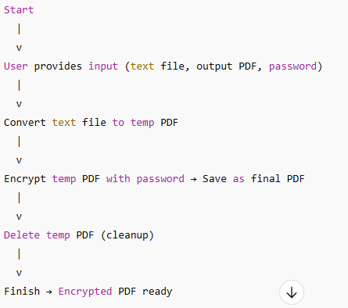

PDF Cracker Tool

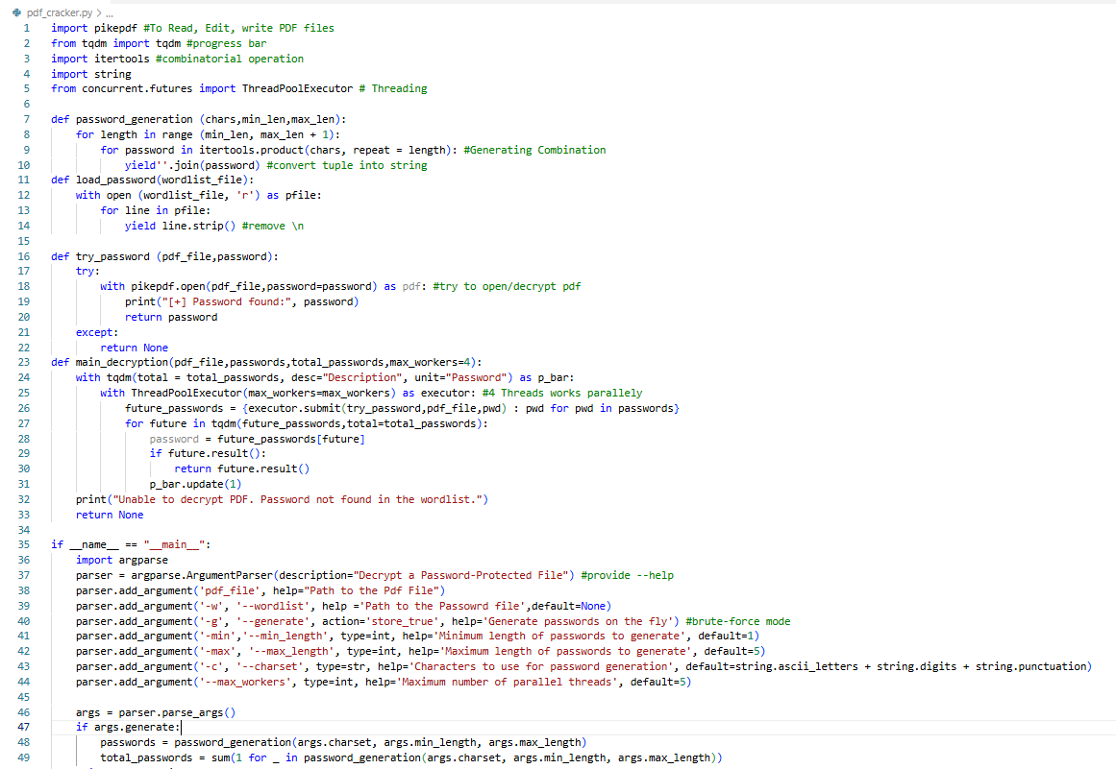
Name: PDF Password Decryption Tool Using Brute Force and Wordlist Attacks
Introduction: This project focuses on developing a Python-based PDF Password Decryption Tool that helps recover access to such protected documents using ethical and authorized methods. The tool demonstrates two popular password-recovery techniques: wordlist-based attacks and brute-force attacks, combined with multi-threading to improve performance.
Technologies used:
Technology / Library | Purpose
Python 3.x | Main programming language
pikepdf | PDF decryption
argparse | Command-line argument handling
tqdm | Progress bar
itertools | Brute-force password combinations
string | Character sets (letters, digits, punctuation)
ThreadPoolExecutor | Multi-threading for faster execution

Working of the Code (Points Only)
- User Input Handling
  - Program takes inputs using argparse (PDF file, wordlist, brute-force mode, charset, length, threads).
- Password Source Selection
  - If wordlist is provided → load passwords from file.
  - If --generate is selected → generate passwords using brute-force.
- Wordlist Loading
  - Reads each line from the wordlist file using a generator (yield).
- Brute-Force Generation
  - Creates all possible character combinations using itertools.product().
- Password Testing
  - Each password is tested on the PDF using pikepdf.open().
- Multi-Threading Execution
  - Uses ThreadPoolExecutor to test multiple passwords in parallel.
- Progress Tracking
  - Shows progress bar using tqdm as passwords are attempted.
- Early Stopping
  - If correct password is found, program stops immediately.
- Final Output
  - If password found → display success.
  - If not found → show “Password not found”.

Flowchart
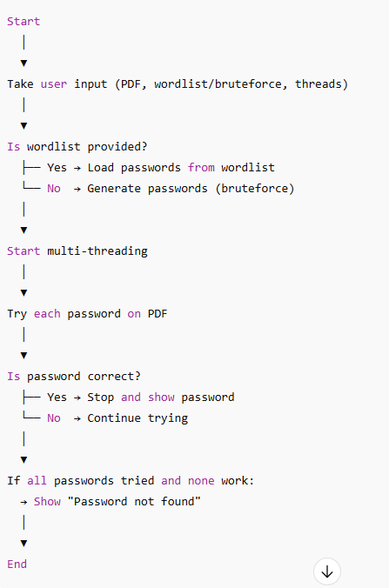

Hash Cracker
–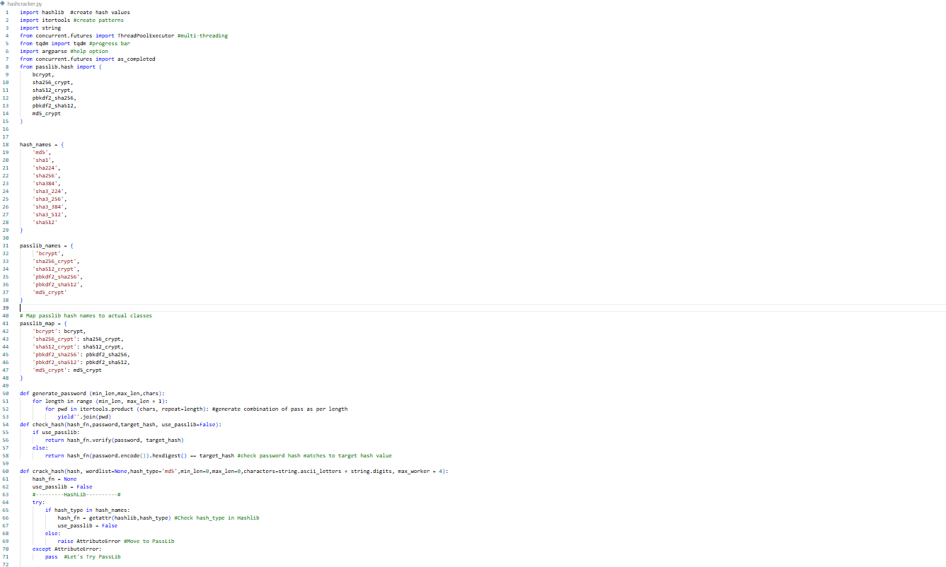
Name: Hash Cracker using Wordlist & Brute-Force
Introduction: designed to crack hashed passwords using two techniques:
- Wordlist Attack
- Brute-Force Password Generation
The tool supports both hashlib algorithms (MD5, SHA-1, SHA-256, etc.) and Passlib secure hashing algorithms (bcrypt, pbkdf2, sha512_crypt, etc.).
Technology used:
Component | Usage
Python 3 | Main programming language
Hashlib | Standard library hashing (MD5, SHA-256, SHA-512, etc.)
Passlib | Advanced hashing algorithms (bcrypt, sha512_crypt, etc.)
Itertools | Password combination generator
ThreadPoolExecutor | Multithreading password cracking
Tqdm | Progress bar visualization
Argparse | CLI argument handling

Flowchart
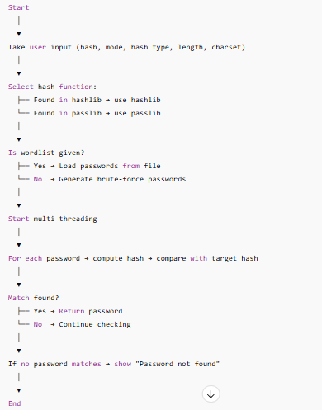

Network Scanner

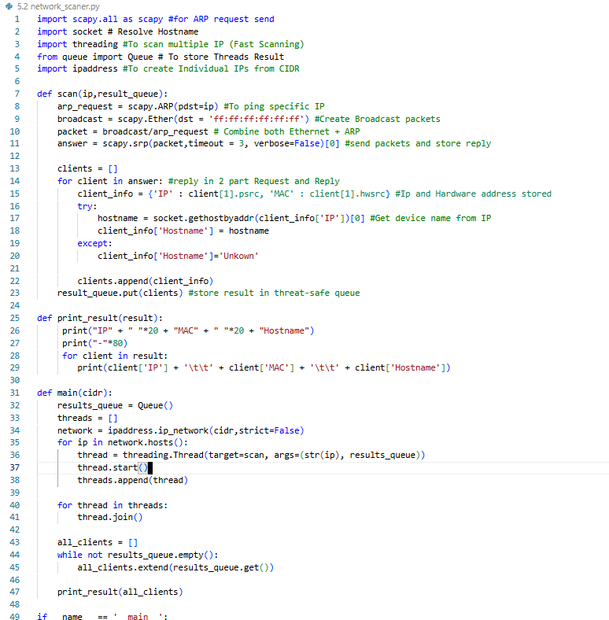

Introduction
This project demonstrates a Python-based Active Network Scanner that scans devices in a LAN network using the ARP protocol. The tool performs discovery, collects IP addresses, MAC addresses, and attempts hostname resolution to provide meaningful device identity information.

Tools & Library used
Component | Purpose
Python 3 | Programming Language
Scapy | Used for ARP packet crafting and sending
Socket | For hostname resolution
Threading | For parallel scanning
Queue | To safely store results from multiple threads
ipaddress module | To expand CIDR into individual IP addresses

Working Principles
The project uses the ARP (Address Resolution Protocol) to detect active hosts. The scanner broadcasts ARP requests to every IP in the specified network range. Active devices reply with their IP and MAC address.
Workflow:
- User enters an IP range in CIDR format (e.g., 192.168.1.0/24).
- The program generates all valid host IPs inside the subnet.
- Each IP is scanned using an ARP request.
  - If a device responds, its:
  - IP
  - MAC address
  - Hostname (via reverse DNS lookup)
are recorded.
- All results are printed in a structured table format.

FlowChart
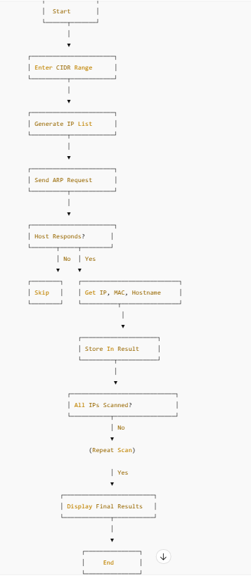

Port Scanner
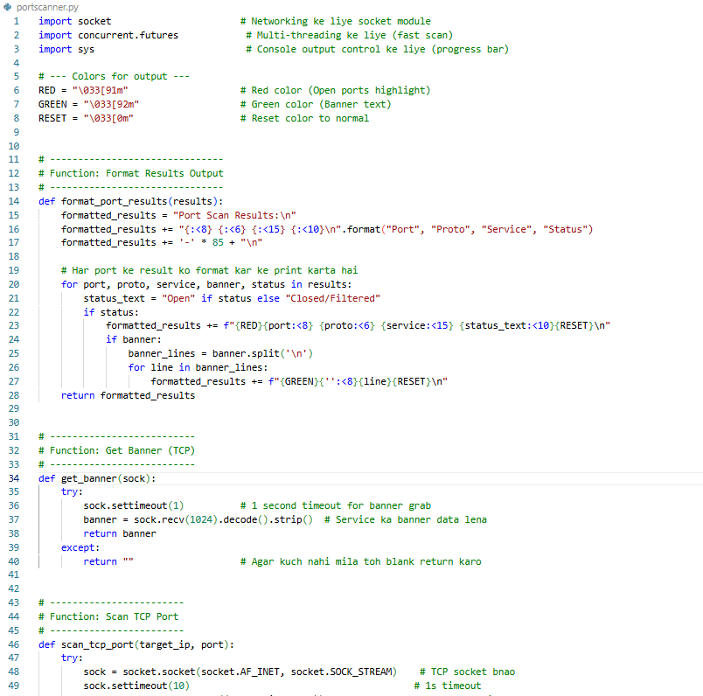

Introduction
A port scanner is a cybersecurity tool used to identify open, closed, or filtered ports on a device or server. These ports are communication endpoints used by services like HTTP (port 80), SSH (22), FTP (21), etc. Ethical hackers and SOC analysts perform port scanning to:
- Detect vulnerable running services
- Identify unauthorized open ports
- Assess firewall and network configuration
- Perform penetration testing and reconnaissance
This project implements an advanced high-speed scanner capable of scanning both TCP and UDP ports, capturing banners, identifying services, and using multi-threading to improve efficiency.

Tools & Library used
Tool / Library | Purpose
Python 3.x | Programming language for developing the port scanner.
socket | Establish TCP/UDP connections and perform banner grabbing.
concurrent.futures | Multi-threading to scan multiple ports simultaneously for faster execution.
sys | Display real-time progress bar and control console output.
ANSI Escape Codes | Color formatting for open ports and banner display.
Terminal / CLI | Execution environment for running the Python script.

Flowchart
